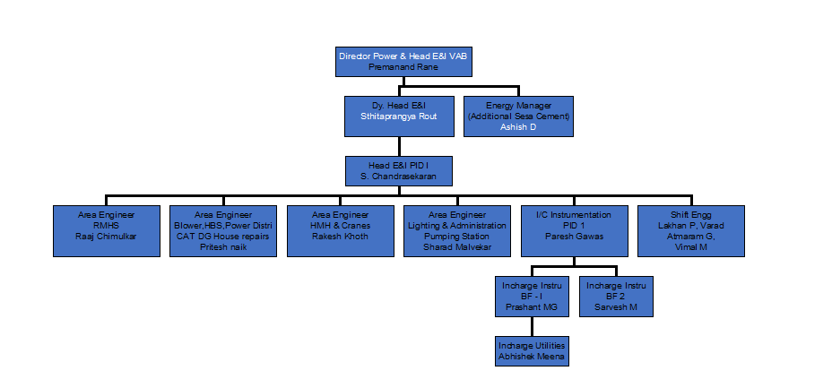

|  |  |  |
| --- | --- | --- |
| **Prepared By:**  Head Instrumentation PID1 | **Reviewed & Issued By:**  Management Representative | **Approved By:**  Head – Electrical & Instrumentation PID1 |
| **Signature:** | **Signature:** | **Signature:** |
| **Date:** 13.09.2023 | **Date:** 13.09.2023 | **Date:** 13.09.2023 |